**Broadcast English text**

## 1. Purpose

In this lesson, we will learn how to use jetson nano drive the speech synthesis module to realize the English broadcast function.

**2.Preparation**

**2.1 About wiring**

|  |  |
| --- | --- |
| Speech synthesis module | jetson nano board |
| SDA | SDA |
| SCL | SCL |
| VCC | 5V |
| GND | GND |

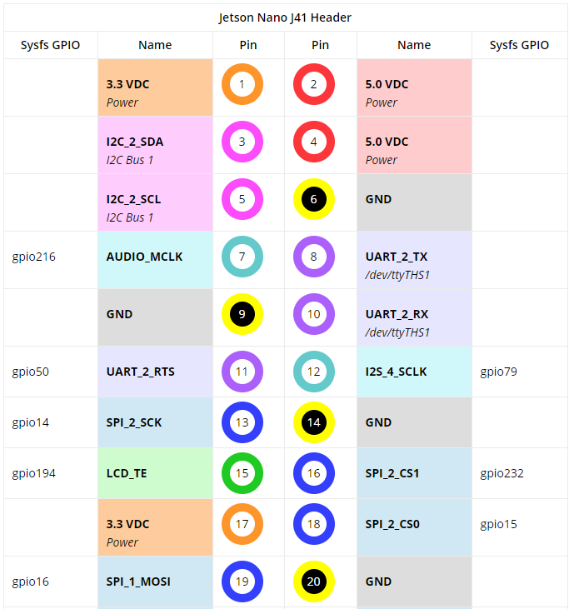

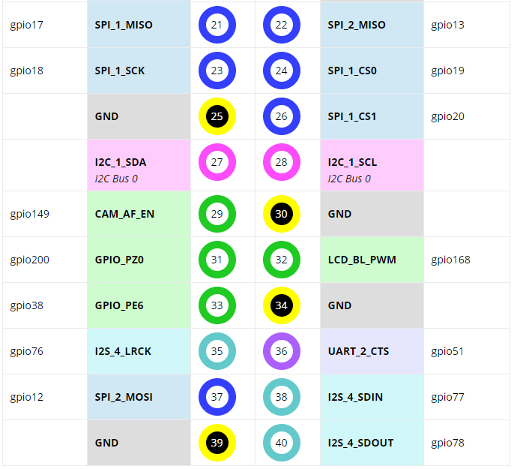

2.2 You need to open the IIC service of jetson NANO board.

2.3 Install I2Ctool

Input following command in command terminal,

sudo apt-get update

sudo apt-get install -y i2c-tools

Wait patiently for the successful installation to complete.

2.4 Check whether the installation is successfully

Input following command in command terminal,

apt-cache policy i2c-tools

If system output is as follows, the installation is successful.

i2c-tools:

Installed: 4.0-2

Candidate: 4.0-2

Version list:

*** 4.0-2 500

500 http://ports.ubuntu.com/ubuntu-ports bionic/universe arm64 Packages

100 /var/lib/dpkg/status

2.5 Scan all i2c devices on a certain bus, and print out the device i2c bus address.

sudo i2cdetect -y -r -a 1

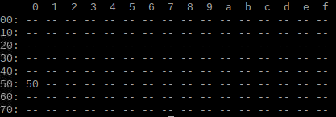

2.6 Install smbus

Input following command in command terminal,  
sudo apt-get update  
sudo apt-get install -y python3-smbus

****3. S**peech synthesis **module protocol****

The speech synthesis module is configured and used in accordance with the specified data frame through the I2C communication.

More details, please check [1.Introduction]--[1.2Communication protocol].

1. **Code**

About code, please view **English_speech.py** file.

**5. Running code**

Input following command in command terminal of jetson nano.

python3 English_speech.py

**6. Experimental phenomena**

After the program is downloaded successfully, Xiaoping will broadcast "hello yahboom intelligent Technology".

Then, Xujiu will broadcast "Welcome to use yahboom intelligent technology voice broadcast module.